

**NAME:**

**Parent Signature:**

12 ATMAM TEST 4

**Section 1: / 27**

**Section 2: / 32**

**Total: / 59**

**%**

Material required/recommended for this test

To be provided by the supervisor

Question/answer booklets for Sections One and Two.

SCSA 12 Formulae Sheet

To be provided by the candidate

Section One:

Standard items: pens, pencils, pencil sharpener, highlighter, eraser, ruler

Special materials: drawing instruments, templates, no notes, formula sheet

Section Two:

Standard items: pens, pencils, pencil sharpener, highlighter, eraser, ruler

Special materials: drawing instruments, templates, notes on a maximum of one unfolded sheet of A4 paper, double sided, up to three approved calculators, CAS, graphics, or scientific.

Important note to candidates

No other items may be taken into the test room. It is your responsibility to ensure that you do not have any unauthorised notes or other items of a non-personal nature in the test room. If you have any unauthorised material with you, hand it to the teacher before reading any further.

STRUCTURE OF SECTION 1

|  |  |  |  |  |  |
| --- | --- | --- | --- | --- | --- |
| Section | Number  of  questions  available | Number  of  questions  to  be  answered | Working  time  (minutes) | Marks  available | Percentage  of Test |
| Section  One:  Calculator-free | 4 | 4 | 30 | 27 |  |
| Section  Two:  Calculator-assumed |  |  |  |  |  |
| Total | | | | |  |

**Question 1. (6 marks: 2, 2, 2)**

The discrete random variable X is defined by

P(X=x) =

1. Determine the value of the constant k.

1. Determine
2. E(5 – 3X)

1. Var(1 + 6X)

**Question 2. (4 marks: 2, 1, 1)**

The road statistics for a country for one year showed that motorcyclists in the age range 15 to 59 had died with the distribution of the ages of these riders shown in the table.

1. Construct a relative frequency histogram of this data.



|  |  |  |
| --- | --- | --- |
| Age(yrs) | Drivers killed | Rel freq |
| 15 ≤ x <20 | 40 | 0.215 |
| 20 ≤ x <25 | 59 | 0.317 |
| 25 ≤ x <30 | 29 | 0.156 |
| 30 ≤ x <35 | 19 | 0.102 |
| 35 ≤ x <40 | 16 | 0.09 |
| 40 ≤ x <45 | 11 | 0.06 |
| 45 ≤ x < 50 | 8 | 0.04 |
| 50 ≤ x <55 | 2 | 0.011 |
| 55 ≤ x < 60 | 2 | 0.011 |

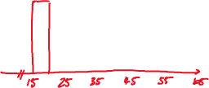

b) Use the graph to estimate the probability of a fatality being a motorcyclist aged under 40.



c) Use the graph to estimate the probability of a fatality being a motorcyclist aged between 36 and 45.



**Question 3. (5 marks: 1, 1, 2, 1)**

Albert discovered an old die, which wobbled when he rolled it.

He rolled it many times and recorded the results.

The relative frequencies are shown in the histogram as shown.

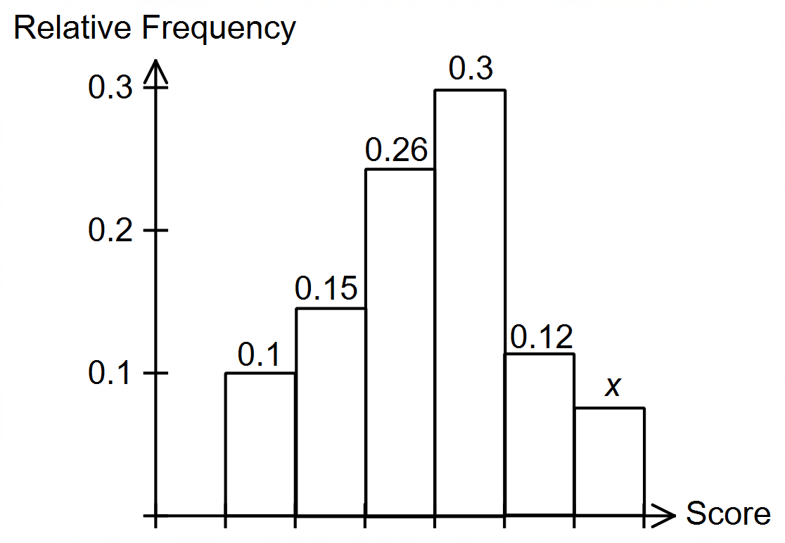

(a) What is the value of x?

0.07. **✓**

(b) What is the probability that the next roll would result in a 1 or a 2?

0.25. **✓**

(c) What is the probability that the next two rolls would both result in a 1 or

both in a result of a 2?

P(1) = (0.1)2 = 0.01.

P(2) = (0.15)2 = 0.0225. **✓**

∴ P(1) + P(2) = 0.0325. **✓**

1. How does this histogram compare with a histogram for an unbiased die?

An unbiased dice would be uniform. **✓**

Question 4. (6 marks: 1, 4, 1)

A triangular probability density function is defined on the domain with a maximum value at

the centre.

(a) Sketch a graph to show the probability density function

(b) Write an expression for the probability density function

(c) Find P (X )

**Question 5. (6 marks:1, 2, 1, 2)**

A continuous random variable X is uniformly distributed in the interval 2 ≤ x ≤ 8. Find:

1. The probability density function of X

F(x) = **✓**

1. Sketch the PDF of X

1. Find P(4 < X < 6)

= x( 6 – 4) = x 2 = **✓**

1. Find P(X < 6 | X > 4)

= = = ÷ = **✓**



**NAME:**

**Section 2: / 32**

12 ATMAM TEST 2

CALCULATOR ASSUMED

Show all your working clearly. Your working should be in sufficient detail to allow your answers to be checked readily and for marks to be awarded for reasoning. Incorrect answers given without supporting reasoning cannot be allocated any marks. For any question or part question worth more than two marks, valid working or justification is required to receive full marks. If you repeat any question, ensure that you cancel the answer you do not wish to have marked.

STRUCTURE OF SECTION 2

|  |  |  |  |  |  |
| --- | --- | --- | --- | --- | --- |
| Section | Number  of  questions  available | Number  of  questions  to  be  answered | Working  time  (minutes) | Marks  available | Percentage  of Test |
| Section  One:  Calculator-free |  |  |  |  |  |
| Section  Two:  Calculator-assumed | 5 | 5 | 30 | 32 |  |
| Total | | | | |  |

**Question 6. (7 marks: 3, 2, 2)**

The following function is a probability density function on the given interval

f(x) =

1. Find the value of a

1. Find the probability that x ≤ 1.2

1. Find the median of the distribution

**Question 7. (9 marks: 2, 3, 4)**

A pizza shop estimates the time X hours to deliver a pizza from when it is ordered is a continuous random variable with probability density function given by

1. What is the probability of a pizza being delivered within half an hour of being ordered?

1. Calculate the mean delivery time to the nearest minute.

1. Calculate the standard deviation of the delivery time to the nearest minute.

**Question 8. (7 marks: 1, 2, 4)**

A school has analysed the examination scores for all its Year 12 students taking Methods as a subject. Let X = the examination percentage scores of all the Methods Year 12 students at the school. The school found that the mean was 75 with a standard deviation of 22.

Determine the following;

1. E( X + 5)

1. Var( 25 – 2X)

The school has decided to scale the results using the transformation Y = aX + b where a and b are constants and the Y = the scaled percentage scores. The aim is to change the mean to 60 and the standard deviation to 15.

1. Determine the values of a and b.

Question 9 (9 marks: 2, 2, 3, 2)

Ravi runs a dice game in which a player throws two standard six sided dice and the sum of the uppermost faces is calculated. If the sum is less than five, the player wins $20. If the sum is greater than eight the player wins $10. Otherwise the player receives no money.

1. Complete the table below

|  |  |  |  |
| --- | --- | --- | --- |
| Amount won |  |  |  |
| Probability |  |  |  |

1. What is the expected amount of money won by a player each time they play?

1. Liu Yang decided to play the game. If Ravi charges $5 to roll two dice, who is likely to be better of in the long-term? Explain.

1. If Ravi wants to make a long term profit per game of 20% of what he charges, what should he charge a player to roll the two dice?

